**Spoti-find User Manual**

Table of Contents

Section 1: Installation 2

Installation 2

MAC 2

PC 6

Running the program 7

MAC 7

PC 7

Section 2: Calibration 8

Opening an Existing Calibration 8

Creating New Calibration 10

Rectangle option 12

Polygon Option 14

Section 3: Operation 16

Data Setup and Visualization 16

Paper Identification 19

Void Spot Identification 21

Rectangle Identification 22

Polygon Identification 26

Saving and Opening Prior Work 28

Section 4: Validation 29

# Section 1: Installation

## Installation

The required files can be found at <https://github.com/TheJacksonLaboratory/Spoti-find>. You can download the required documents or you can download them using git commands.

### MAC

For the program to run you will need a miniforge installed on your computer. If you do not have that you can get it here: <https://github.com/conda-forge/miniforge>

Miniforge Installation:

Then in the search bar type terminal

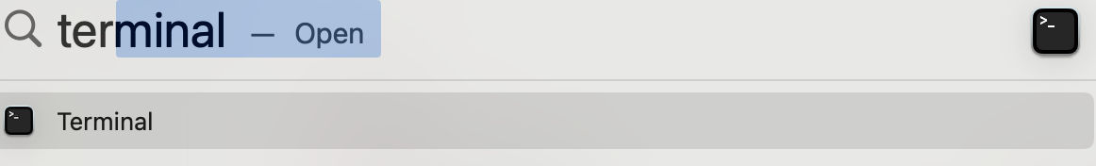

You should get a screen that looks like this

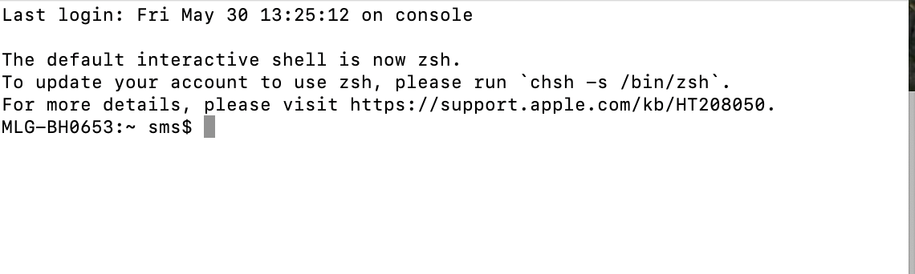

In the terminal window Navigate to where you downloaded the file that ends in “.sh”. To do this, you type “cd” for Change Directory and then the file name that matches your download.

Type blue exact and green specific to your computer

cd path-to-your file



You can check if you are in the correct place by using the list command (ls)

ls

Then type “bash” and the file name that matched your computers specifications, followed by “.sh”.

bash Miniforge3-MacOSX-arm64.sh



You will then get some automatic text that asked you for some prompts - see below. These will be unique to your computer and the location where you would like to install the files. In the example we followed the default settings/locations.





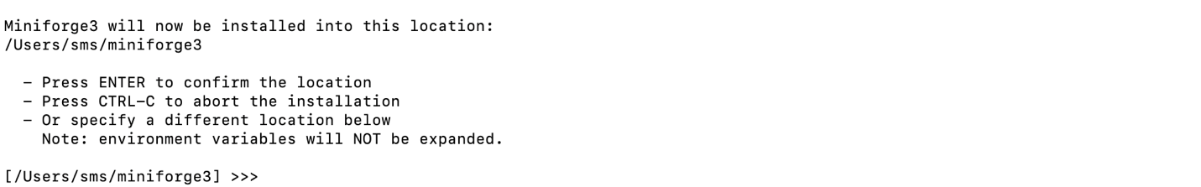

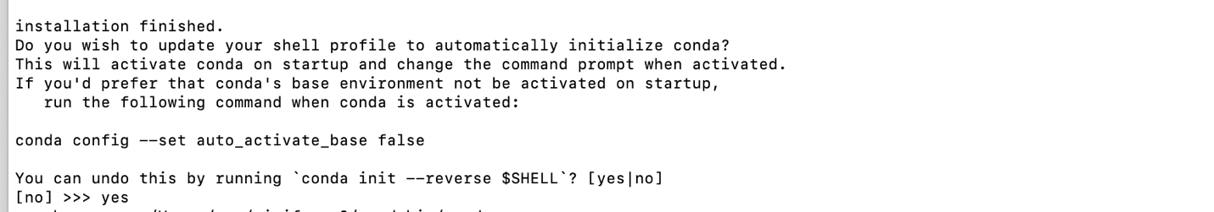

Close the terminal window. This is important to finish the install.

Next, we need to get some specific files for the spoti-find program. The files can be found at <https://github.com/TheJacksonLaboratory/Spoti-find> . If you are familiar with Git commands, you can use the command line and git commands; if you are less familiar with coding you can go to the website. Open the Github website. Click on “code”, then “Download ZIP”.

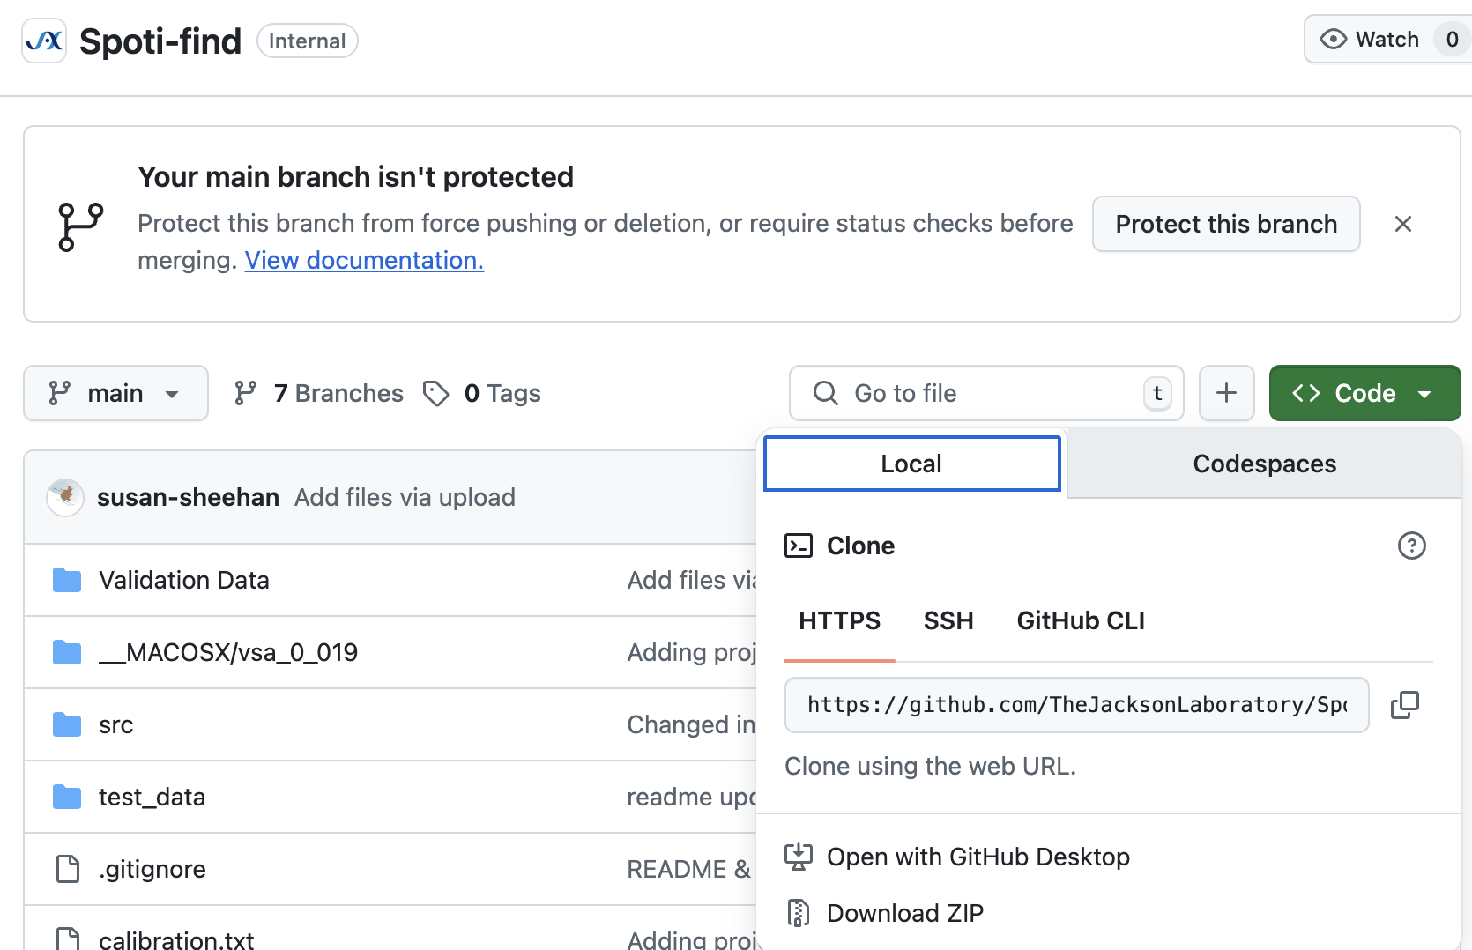

Double click on the zip file to unzip the contents

Return to a new terminal window and navigate to the directory with the files.

cd /Users/sms/Downloads/Spoti-find-main



In the terminal window Type

mamba create --file vsa_enviroment.yaml

Once it’s done type

mamba activate spoti-find-env

Then type

python -m spoti_find

### PC

The files can be found at <https://github.com/TheJacksonLaboratory/Spoti-find>. If you are familiar with Git commands you can use the command line and git commands; if you are less familiar with coding you can go to the website. Open the Github website. Click on “Code” then “Download ZIP”.

Navigate to the folder with the downloads.

Double click on the file VSA_GUI.exe. This will take a few minutes to install. Note: we are not signing the application so you might get a warning window – we recommend clicking to install anyway. If there is a question, source code is provided.

You can then move the VSA_GUI file to your preferred location on your computer.

## Running the program

### MAC

Open a terminal window. In Terminal, navigate to the directory with the spoti-find program

cd path-to-your file

Type

mamba activate spoti-find-env

Then Type

python -m spoti_find

A new application window should open:

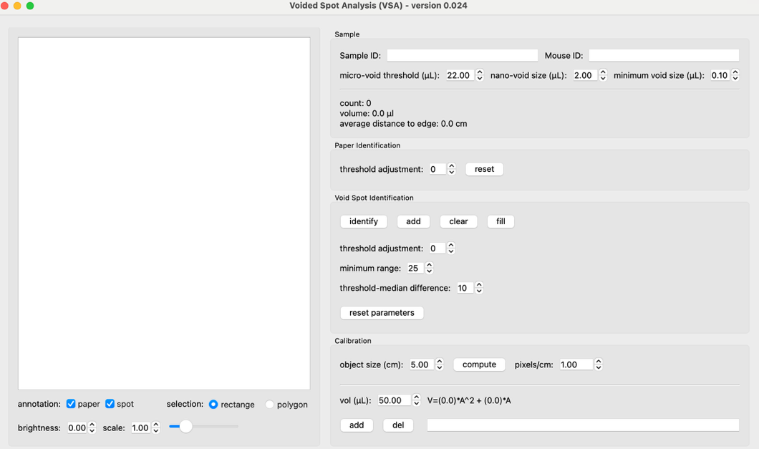

### PC

Double click on the VSA_GUI file. The application should open.

# Section 2: Calibration

To use the VSA program each session, you must load a calibration paper. We are providing several calibration files ready to use:

|  |  |  |
| --- | --- | --- |
| File Name | Manufacturer | Catalog # |
| WhatmannCalibration.txt | Cytiva Whatman™ Qualitative Filter Paper: Grade 1 Sheets | 1001929 |
| ChromatographyCalibration.txt | Thick Chromatography Paper, Grade 238, Ahlstrom | 2381-1417 |

We also have a blank calibration file (Calibration.txt) for you to establish your own paper. These papers link the volume to area.

## Opening an Existing Calibration

Go to the file option and select “Load Calibration…”

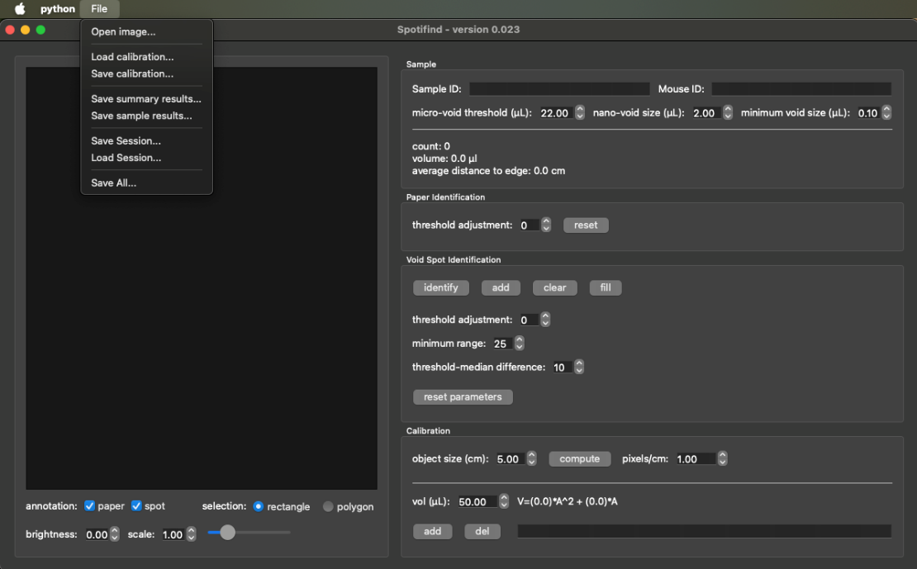

A window will open with your file system in it. Open the .txt file that matches your paper. In the example, we have selected the “WhatmannCalibration.txt” file.

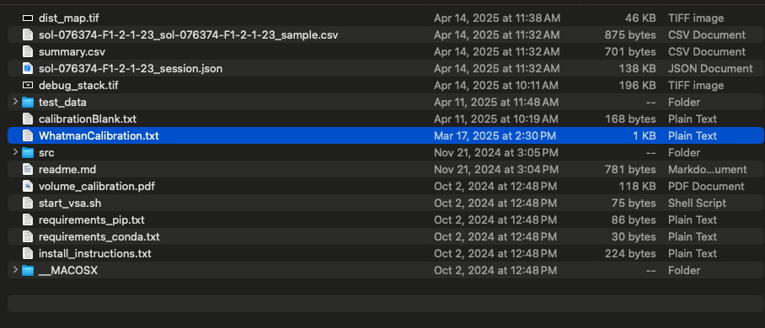

You can confirm that the calibration has loaded by checking the calibration section in the bottom right of the screen:

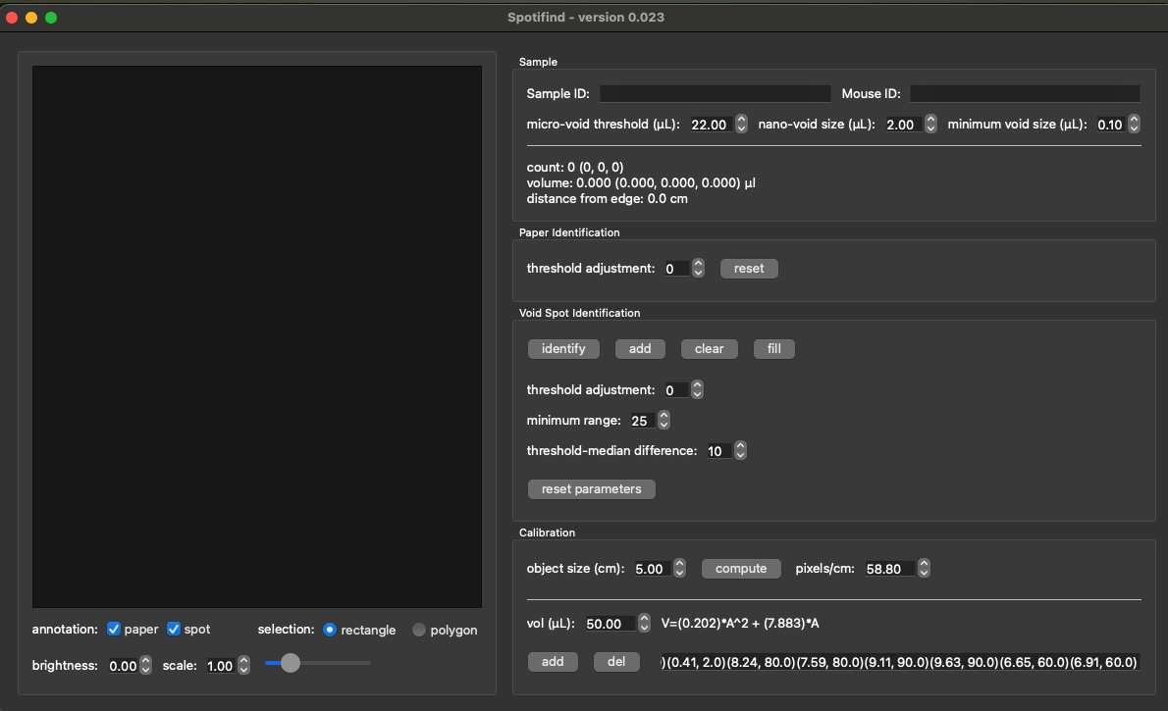

## Creating New Calibration

Using the same procedure as before load in the CalibrationBlank.txt

In this case you will only have one point in the lower right corner:

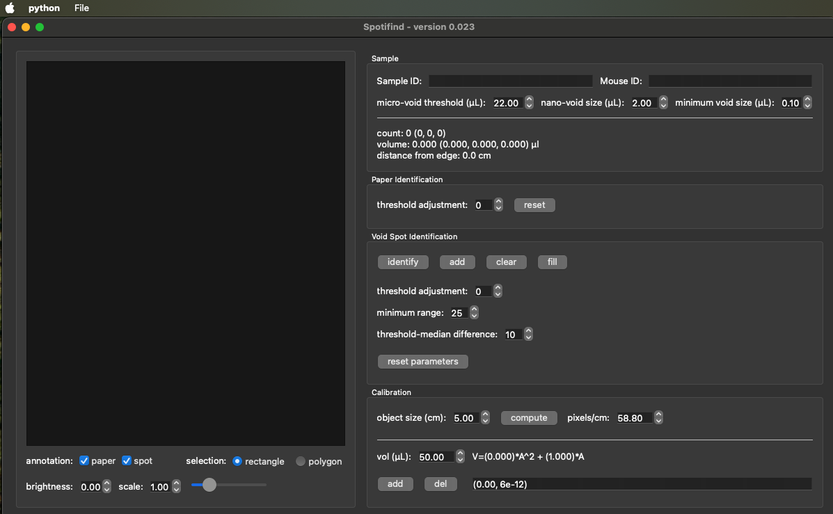

Now Open an Image with spots of known volume by selecting *File> Open Image*

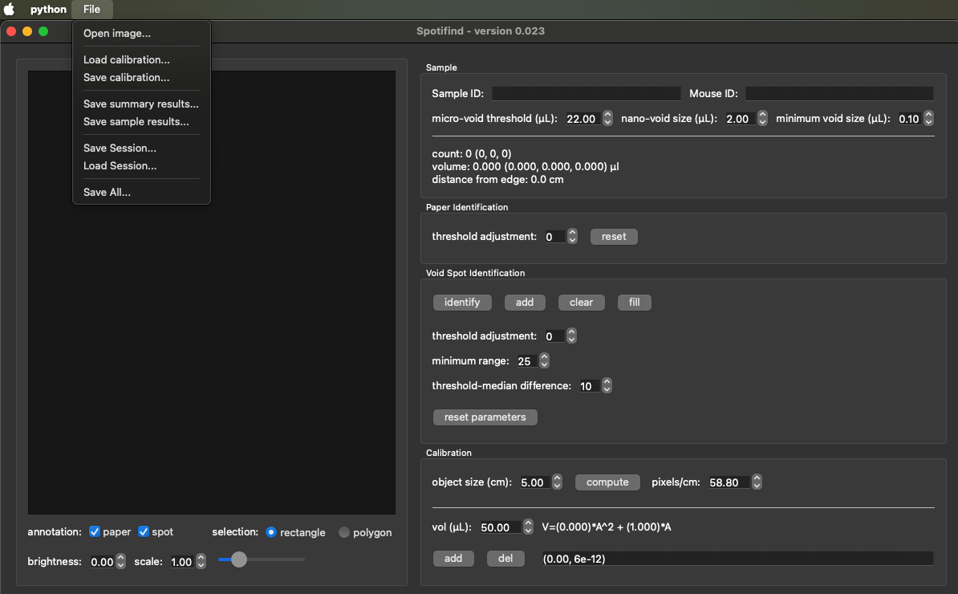

You should now see an Image in the left panel

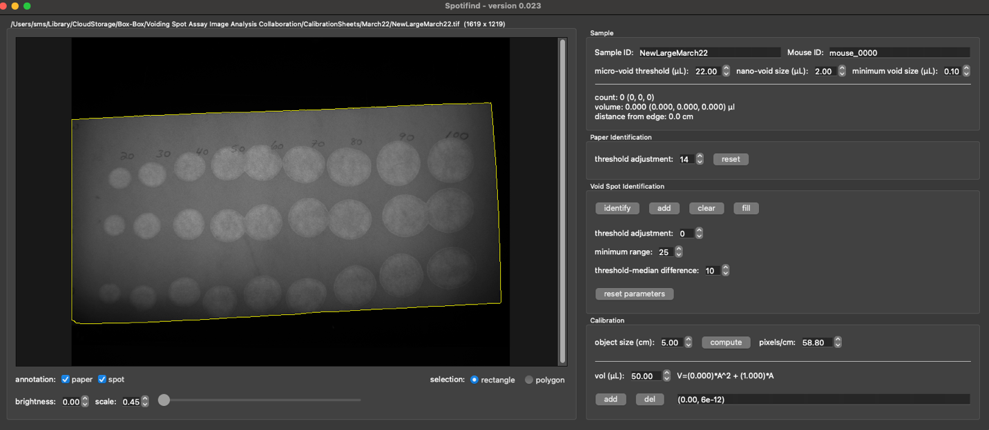

Using one of the selection options rectangles, or Polygon from left middle bottom See below for description.



### Rectangle option

This option works by drawing a rectangle around one or more spots.

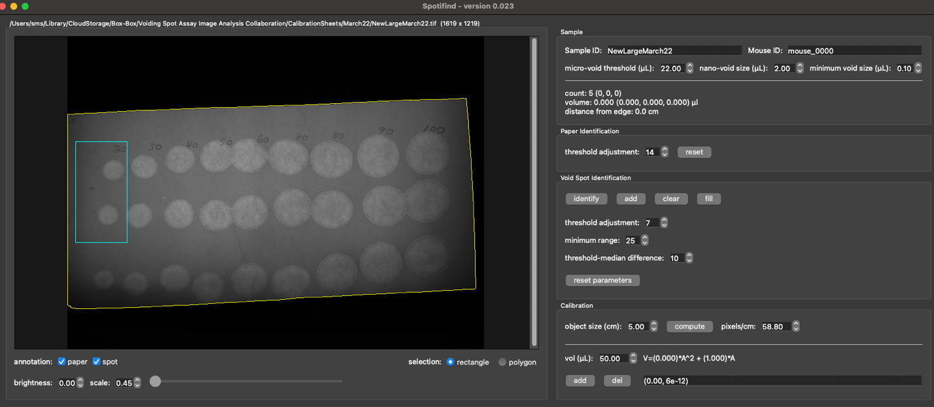

Use the Void Spot identification section in the middle of the right side to identify spots. Hit the identify button and then adjust typically the threshold until the spots are outlined in teal.

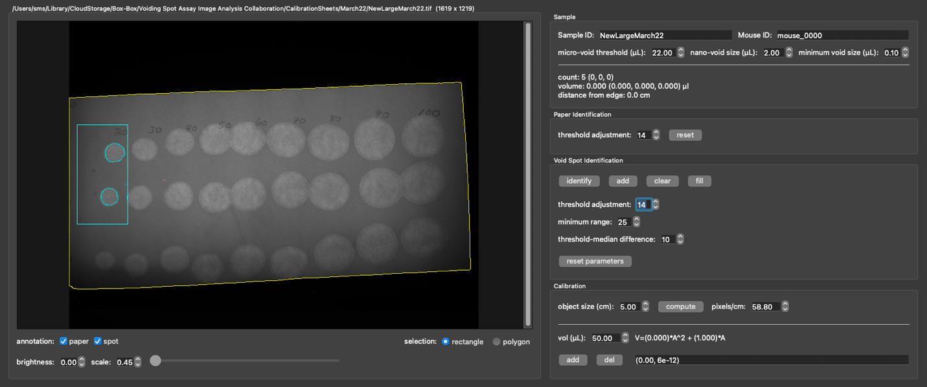

Next adjust the volume of the size spot you have identified in the calibration section on the lower left (20ul in the example) Then click the add button another spot will appear in the list

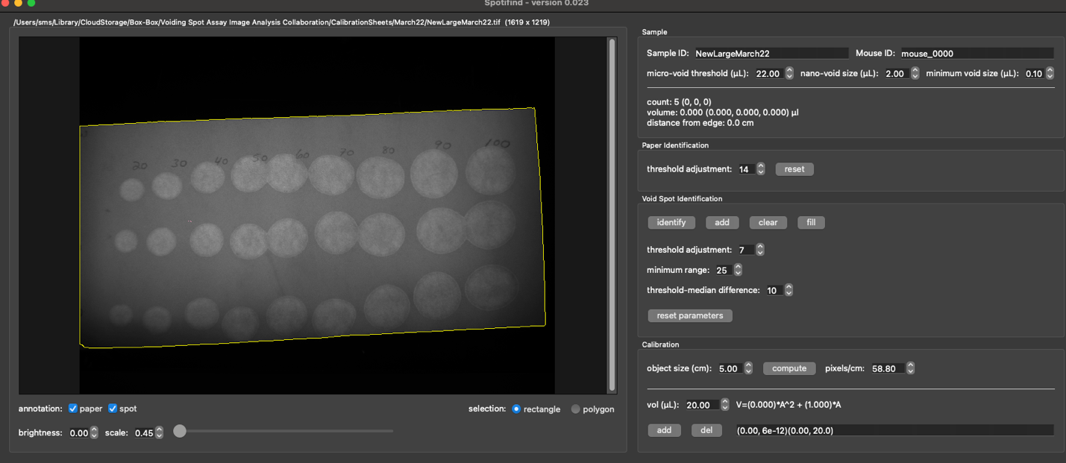

Repeat as needed.

### Polygon Option

For some spots the automatic identification will not work, and you will need to use the polygon option. For this option, choose the Polygon tool:

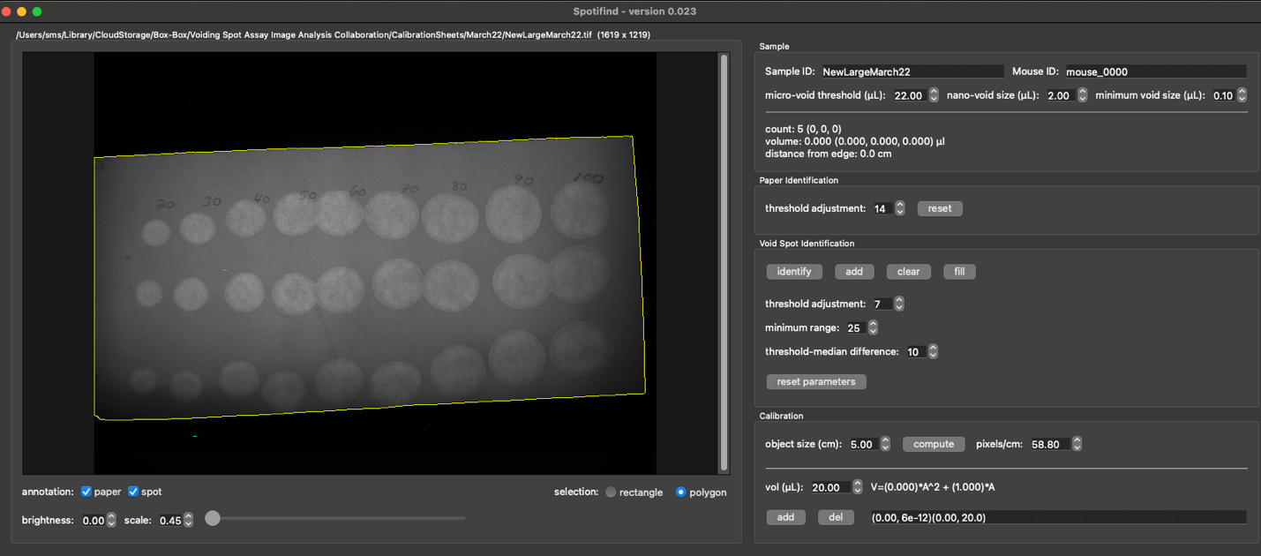

Then, using your mouse outline the spot of interest.

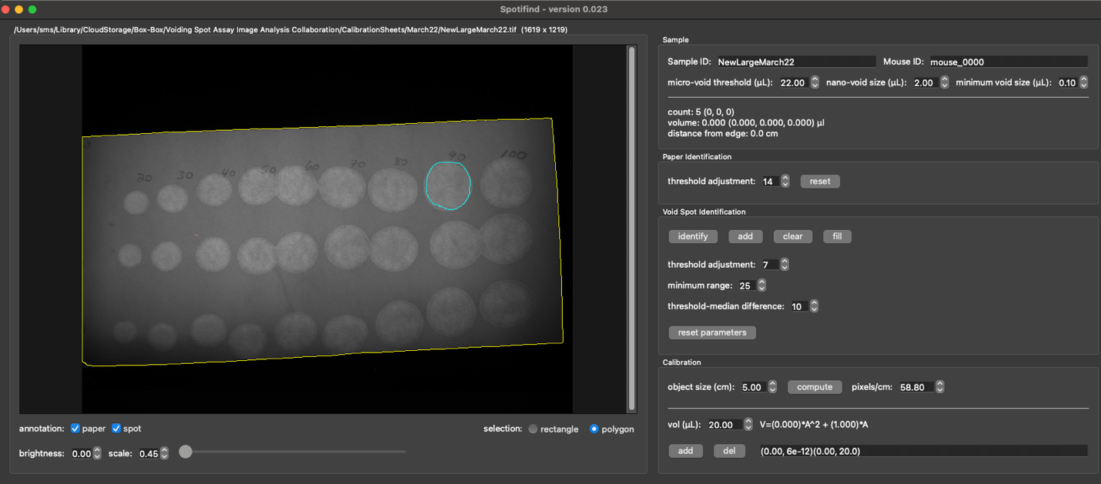

In the “Calibration” section on the right side of the page, change the volume to match the spot and click “add”.

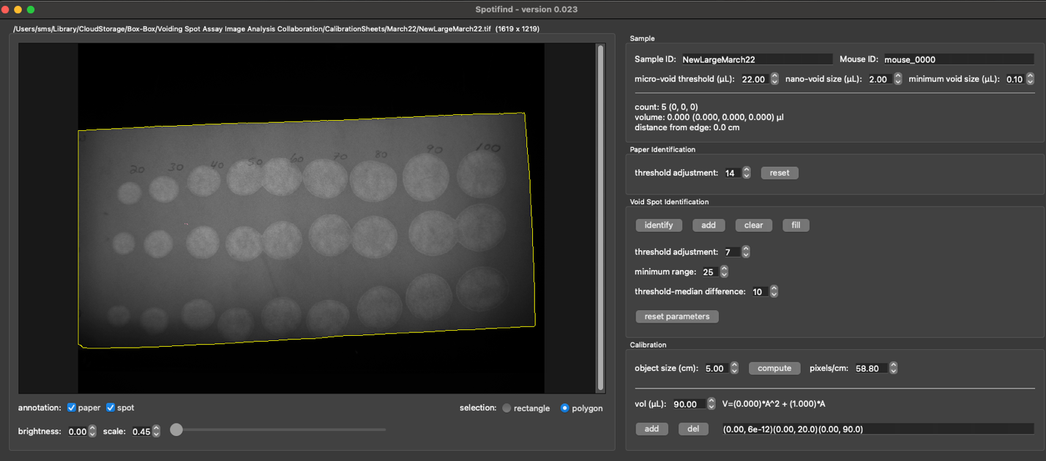

Repeat for as many spots as needed then save the calibration by going to *File>Save Calibration.*

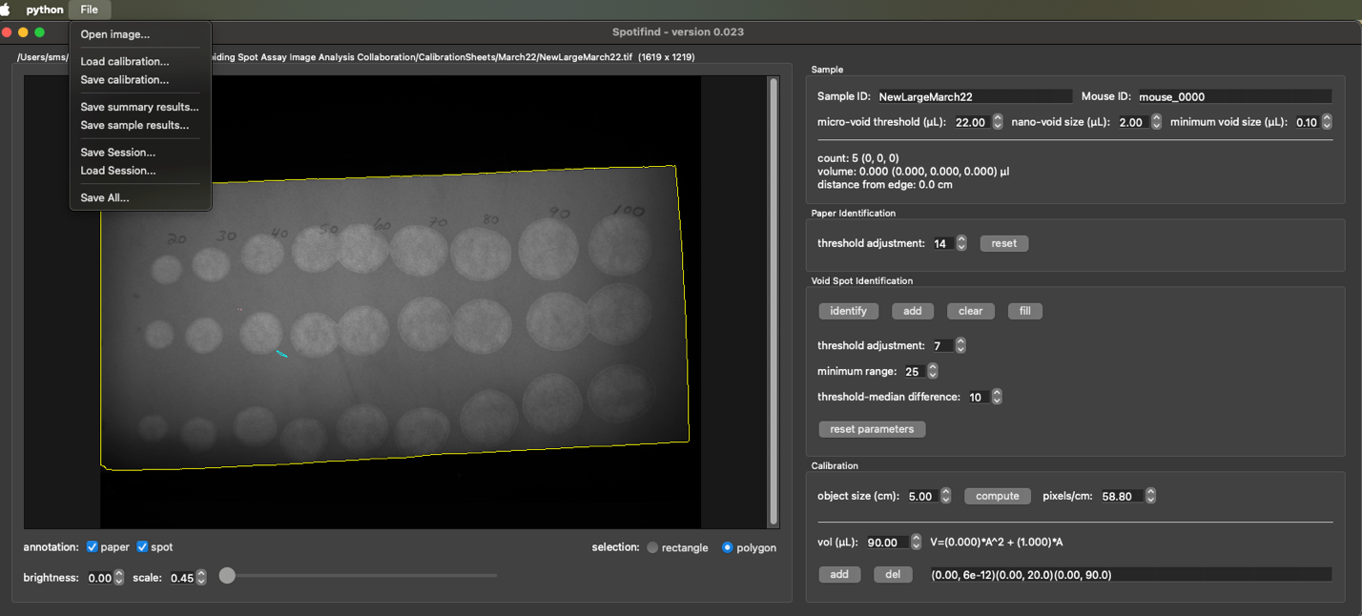

# Section 3: Operation

## Data Setup and Visualization

Open the program (See Section1)

Open a Calibration sheet (See Section2)

Use File>Open Image. In the example I opened the Test_8bit.tif Included in the GitHub repository

Starting at the top of the right panel work down.

Adjust “Sample ID” and “Mouse ID” to fit your experiment. These values will be in the final data. It is highly recommended that your system of identification tracks mouse and day.

Thresholds to use used to identify the micro void, nanovoid and min void are in this window. These do not need to be changed have been set based on XXXX(INCLUDE REFERNCE) but can be easily adjusted based on your model.

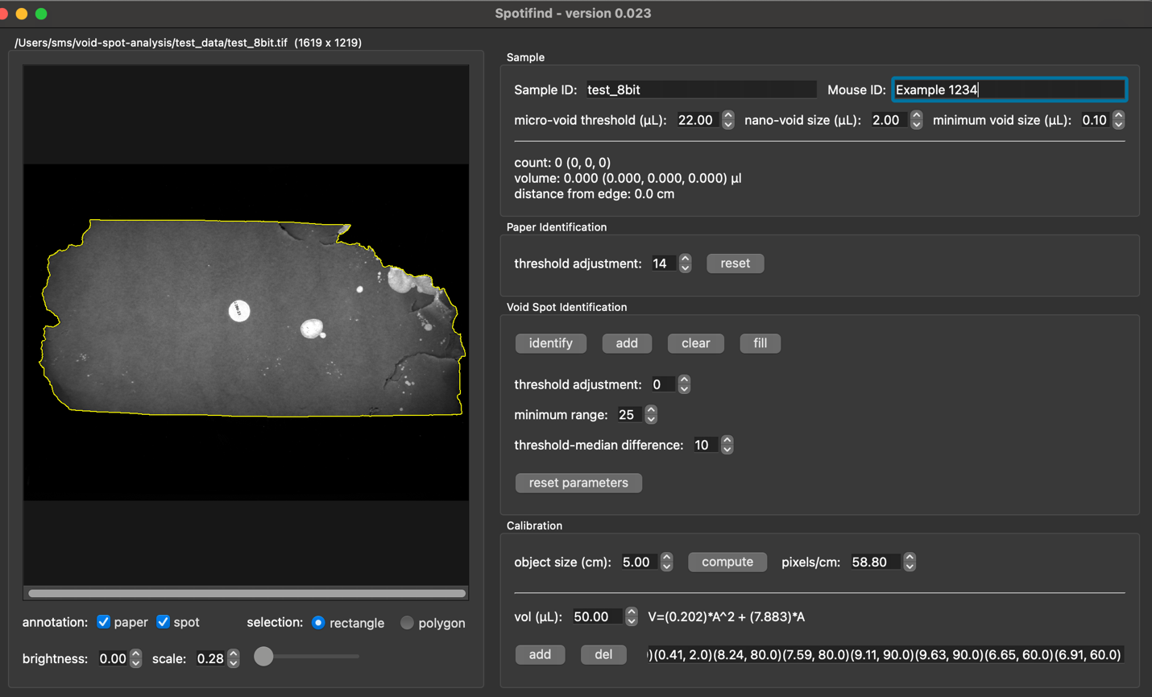

The next section down provides a running count of total number of spots that meet the above criteria



Below the left panel are three options for brightness,line width and scale these can be adjusted for ease of display and spot identification. They are used for display purposes only and do not change the raw image. Brightness is helpful if you have a paper where the spots are hard to visualize and can sometimes be used to help clarify paper edges.

The scale setting can be used to zoom into regions on the paper and either the slider or the numbers can be used, this is helpful if there are many spots on the paper and or if you have spots with lower resolution

The line width can be used for to better visualize the spots as well as to enphisise spots if Images are needed for presentations and publications.

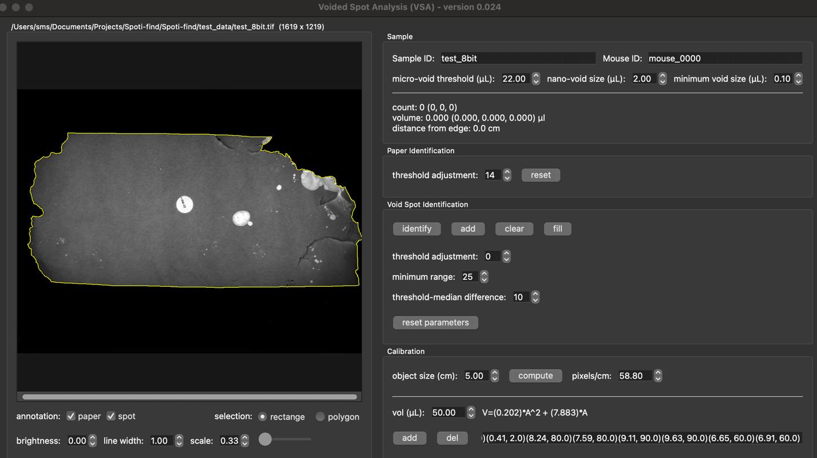

## Paper Identification

Check that the program has identified the paper correctly especially if the lighting is faint. Make sure the paper annotation option is selected at the bottom of the left panel



The paper will be outlined in yellow, and you can adjust the threshold adjustment until it matches the paper outline. If you have been adjusting and you do not like your adjustment simply hit “reset” to return to the default state.

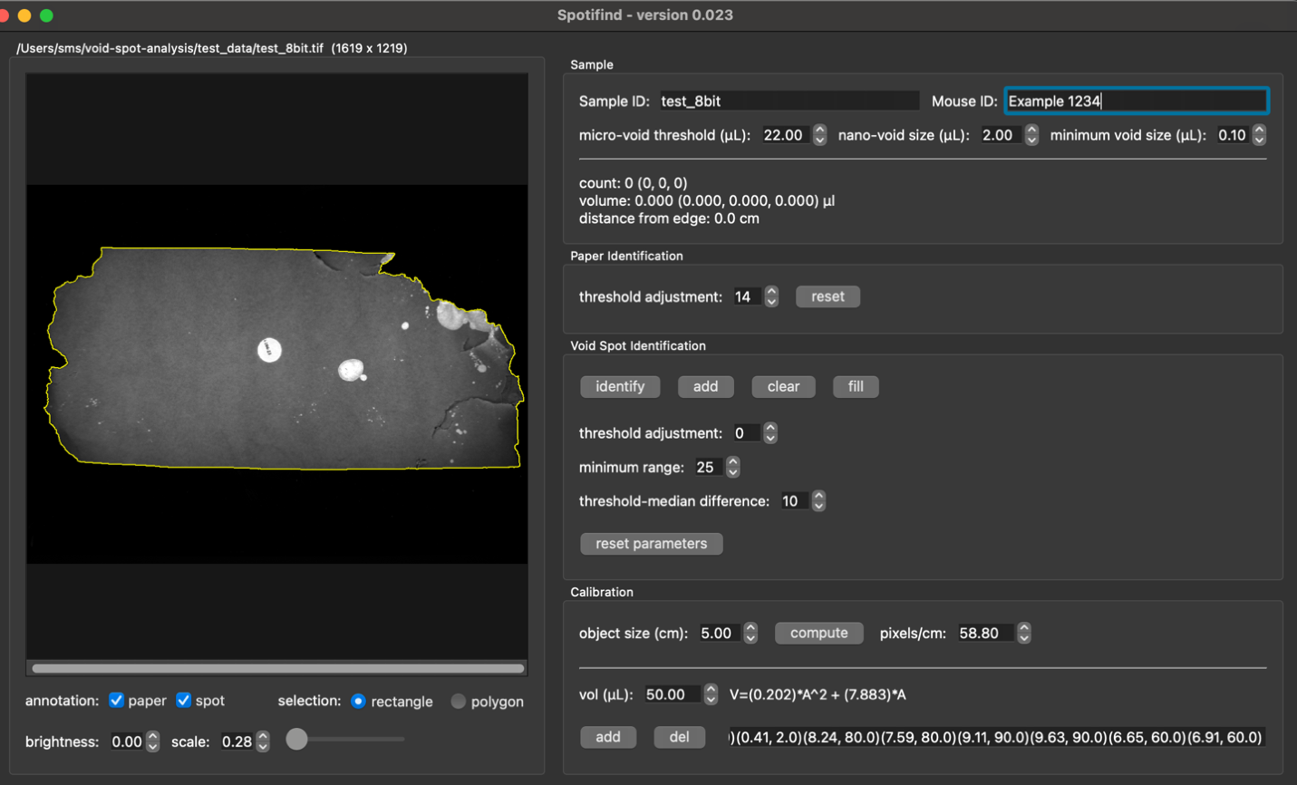

## Void Spot Identification

Continuing down the right panel we now get to the Void Spot Identification. Make sure the spot annotation option is clicked on the bottom of the left panel.



There are two methods to identify spots using the selection option below the left panel: rectangle and polygon.

### Rectangle Identification



To use the rectangle option, select rectangle and draw a box around an area you want to identify spots in. This boundary will be teal as will any tentative spot outlines

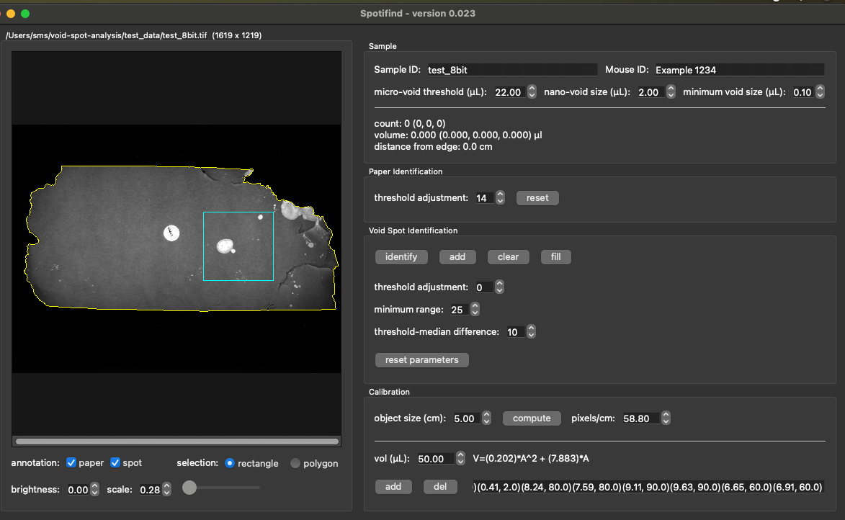

Then hit the “identify” button in the void spot identification section on the right. Tentative outlines will appear in teal and can be adjusted with the parameter settings in this area.

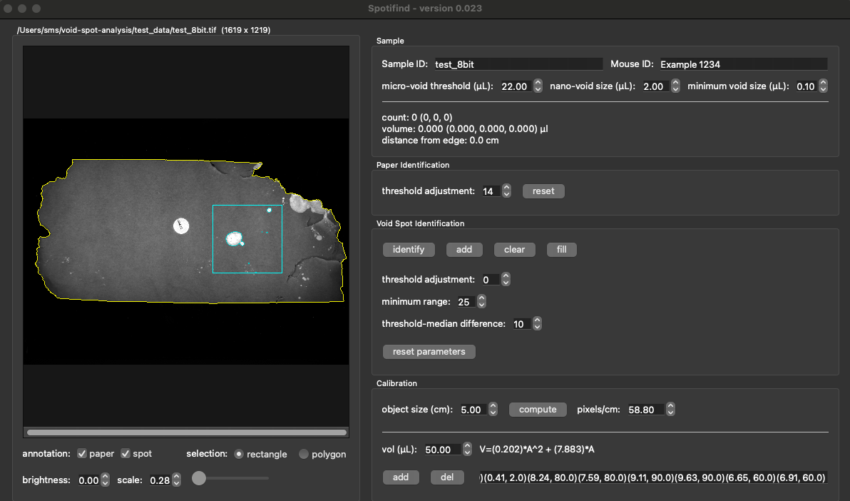

Once you are happy with the selections you hit the “add” button. Tentative selections will change color. The colors will remain with the void classes even if you adjust the void class definitions. The default sizes are listed below.

* Primary Voids – green Spots greater than 22ul
* Micro voids –purple spots between 22ul and 2 ul
* Nano voids –coral spots 2 and 0.1ul
* Noise –pink spots under 0.1ul

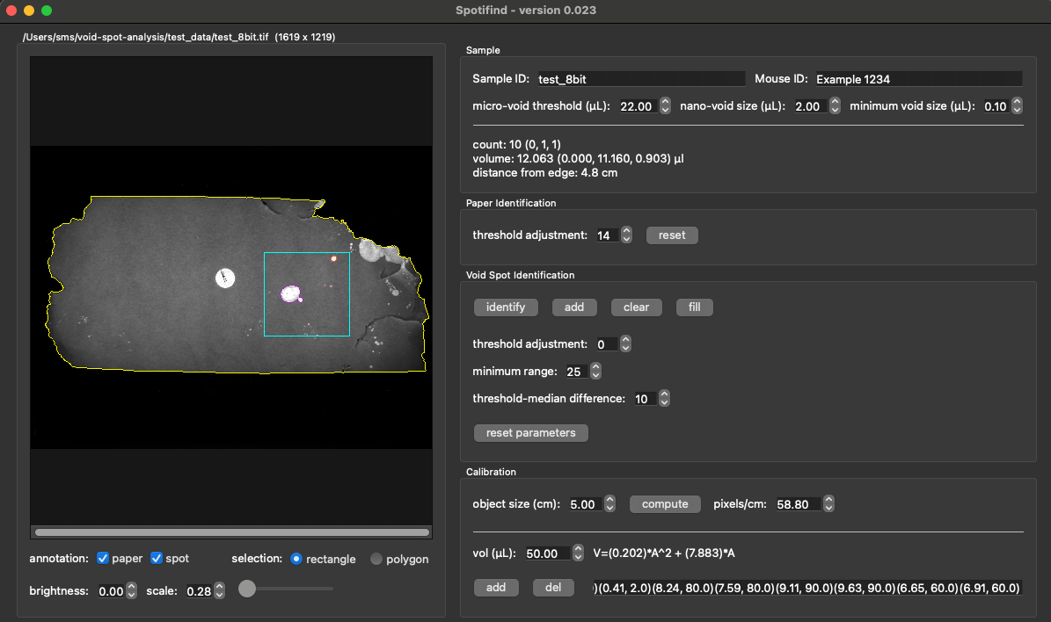

There will likely be instances in which you want to clear a selection. For instance, in the paper below, the identification sticker (numbered dot in the center of the paper) shows up similar to a void spot. If we had erroneously identified it, we can remove the selection by surrounding it with a rectangle selection and clicking the “clear” button.

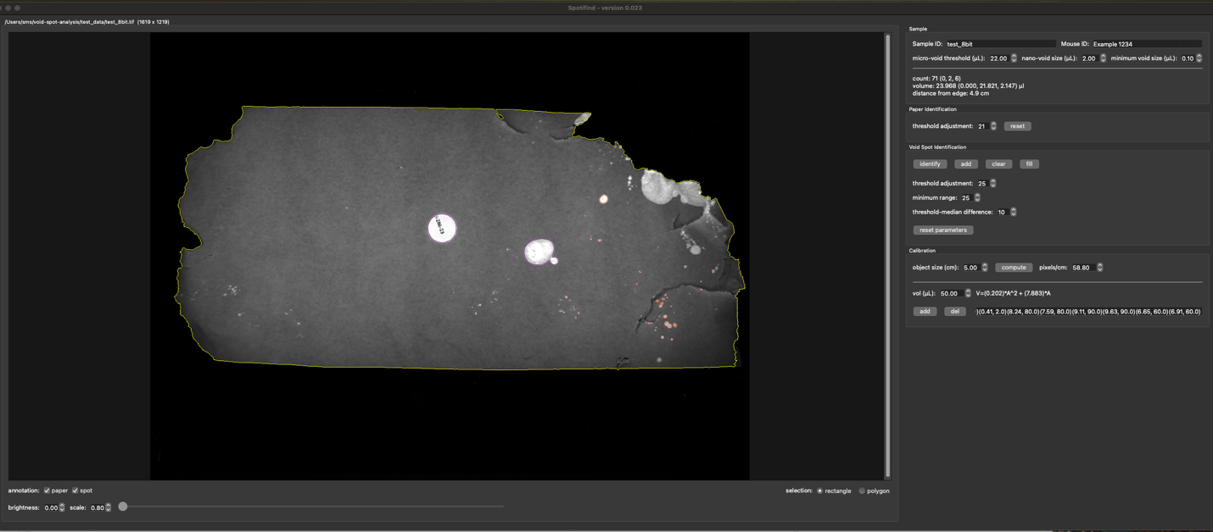

### Polygon Identification

The other Selection option is the polygon tool to use this select the polygon tool at the bottom of the left panel. Then using the mouse outline the spot of interest. Your tentative outline will appear in teal.

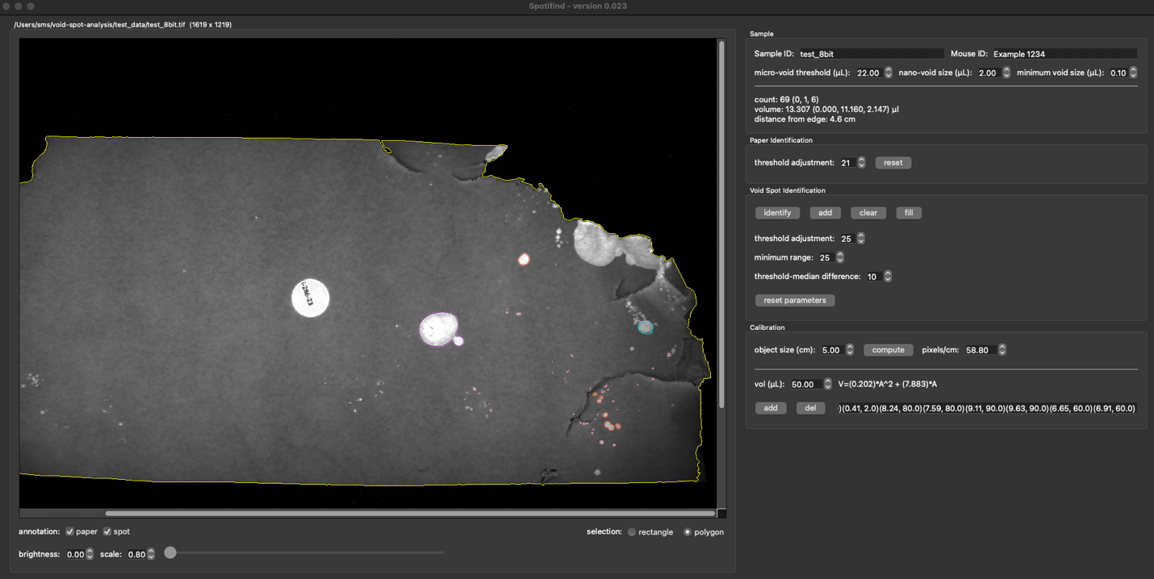

Once you are satisfied with your outline hit the fill button in the void spot identification section and it will be added to the spots on the paper you can tell it has been added by a color change of the outline to the following colors (The volumes listed assume you have not altered the default settings, colors will stay with each void class even if these are adjusted).

* Primary Voids – green Spots greater than 22ul
* Micro voids –purple spots between 22ul and 2 ul
* Nano voids –coral spots 2 ad 0.1ul
* Noise –pink spots under 0.1ul



## Saving and Opening Prior Work

Once all the spots have been identified there are several saving options. Typically, you will want the save all option at the bottom of *File>Save All*:

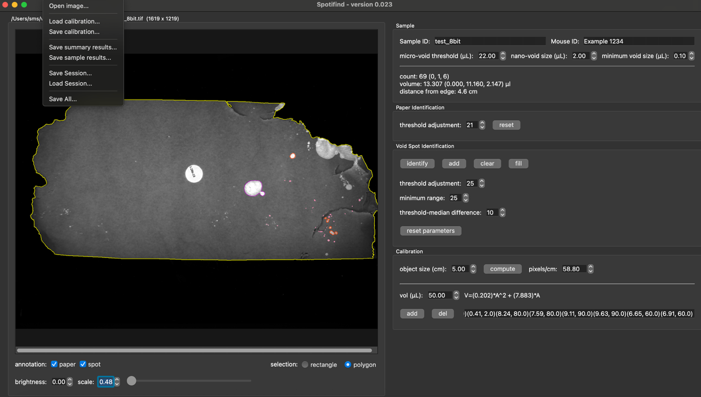

This will save three files:

1. A json session file that will preserve your spot identification for future needs
2. A Sample csv file that will save information about each spot identified
3. A summary csv file that will take summary the paper and with counts and averages.

You can save Each File individually if you want. By using:

*File> Save Session* – for the json file preserving the outlines of each spot

*File>Save Summary results* – for the spot specific detailed data

*File>Same Sample results* – for the summary of the results by paper

If you want to open a previously analyzed paper use File>Load Sesson

# Section 4: Validation

In using the program, void spot identification can be subjective. We have provided a set of 29 papers used in Figure X in the paper for validation. For this data set we also provide 3 prior readers’ scores. We highly suggest that any new user of the program score these papers and test interclass correlation co-efficient (ICC). This is a measure of the reliability of ratings. We provide code (ValdationICC.R) to be able to do this in R but any statistics program should be able to be used. As a general guidance, we suggest the following categories for ICC values:

|  |  |
| --- | --- |
| **Value** | **Interpretation** |
| <0-0.099 | No Agreement |
| 0.01-0.2 | Slight Agreement |
| 0.21-0.40 | Fair Agreement |
| 0.41-0.60 | Moderate Agreement |
| 0.61-0.80 | Substantial Agreement |
| 0.81-1 | Almost Perfect Agreement |

As mentioned in the paper, there are some measurements that are more subjective than others. It is suggested that at least counts be in the Almost Perfect Agreement class and agreement for other measurements be dependent on the relevance to your use case. For instance, if you are using void spot assays to determine urine output then volume should also have a high agreement.

In the R code provided for Each Measurement you test will provide a readout similar to below We suggest using the Average fixed raters as this means the ICC is calculated based on the average readings from multiple users rather than a single reader. This is the number we suggest using in the above interoperation chart.

